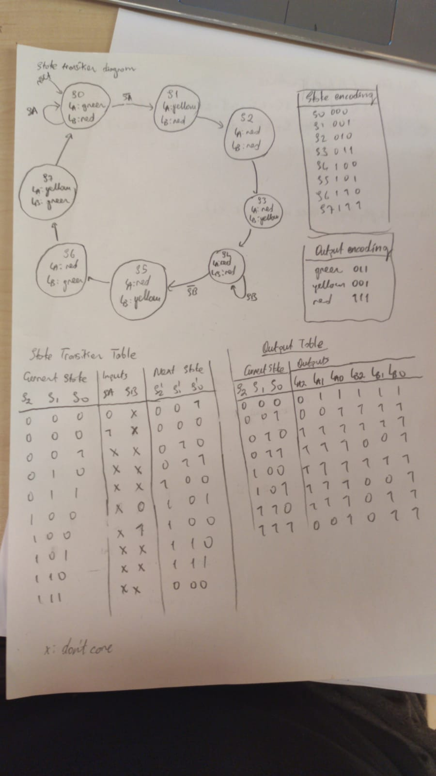

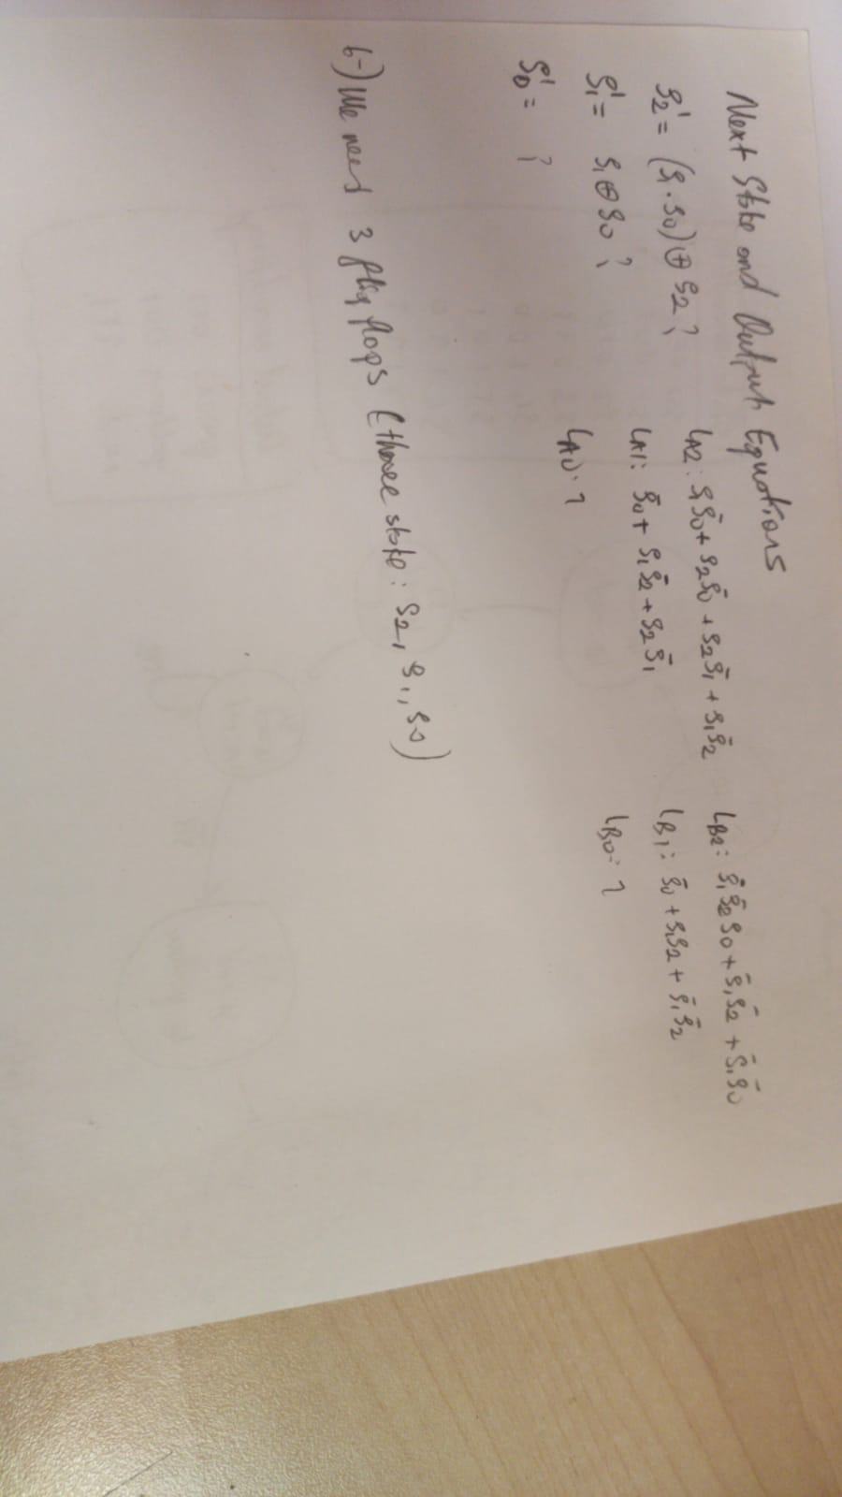

**SystemVerilog code for trafficLights**

module trafficLights(input logic SA,

input logic SB,

input logic clk,

input logic reset,

output logic ledA1, ledA0,

output logic ledB1, ledB0);

typedef enum logic [2:0] {S0, S1, S2, S3, S4, S5, S6, S7} statetype;

statetype[1:0] state, nextstate;

always_ff @(posedge clk, posedge reset)

if(reset) state <= S0;

else state <= nextstate;

always_comb

case(state)

S0: if(SA) nextstate = S0;

else nextstate = S1;

S1: nextstate = S2;

S2: nextstate = S3;

S3: nextstate = S4;

S4: if(SB )nextstate = S4;

else nextstate = S5;

S5: nextstate = S0;

default: nextstate = S0;

endcase

assign ledA1 = (state[2]^state[1]) | (state[1] & state[0]);

assign ledA0 = state[0] & ((~state[2])^state[1]);

assign ledB1 = (~state[2]^state[1]) | (~state[2] & state[0]);

assign ledB0 = state[0] & ((state[2])^state[1]);

endmodule

**SystemVerilog code for clock generator**

module newClock(

input clk,

input rst,

output logic clk_div

);

localparam constantNumber = 150000000;

logic [31:0] count;

always @ (posedge(clk), posedge(rst))

begin

if (rst == 1'b1)

count <= 32'b0;

else if (count == constantNumber - 1)

count <= 32'b0;

else

count <= count + 1;

end

always @ (posedge(clk), posedge(rst))

begin

if (rst == 1'b1)

clk_div <= 1'b0;

else if (count == constantNumber - 1)

clk_div <= ~clk_div;

else

clk_div <= clk_div;

end

endmodule

**testbench for traffic lights**

module trafficLights_tb;

logic SA, SB, clk, reset, ledA1, ledA0, ledB1, ledB0;

trafficLights func (.SA(SA), .SB(SB), .clk(clk), .reset(reset), .ledA1(ledA1), .ledA0(ledA0),

.ledB1(ledB1), .ledB0(ledB0));

initial

begin

reset <= 1; #10;

reset <= 0; SA <= 1; #10;

SB <= 0; #10;

SB <= 1; #10;

SB <= 0; # 10;

end

always begin

clk <= 1; #5;

clk <= 0; #5;

end

endmodule

**trafficlights top design systemverilog code**

module trafficLights_top(input logic SA,

input logic SB,

input logic clk,

input logic reset,

output logic lightA2,

output logic lightA1,

output logic lightA0,

output logic lightB2,

output logic lightB1,

output logic lightB0);

logic clk_div;

logic ledA1, ledA0, ledB1, ledB0;

newClock( clk, reset, clk_div);

trafficLights( SA, SB, clk, reset, ledA1, ledA0, ledB1, ledB0);

assign lightA2 = ~ledA1 & ~ledA0;

assign lightA1 = ~ledA1;

assign lightA0 = 1;

assign lightB2 = ~ledB1 & ~ledB0;

assign lightB1 = ~ledB1;

assign lightB0 = 1;

endmodule

endmodule